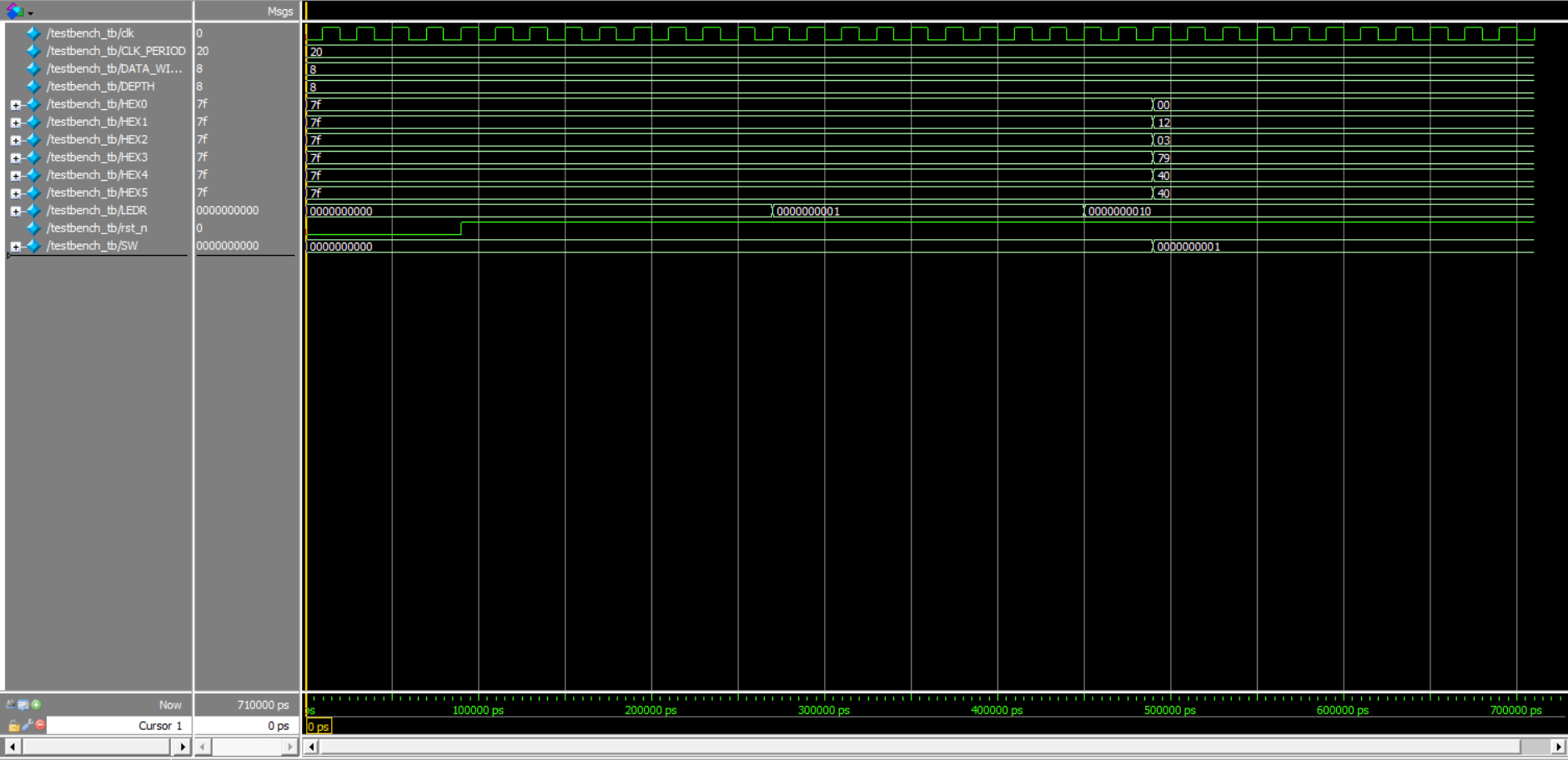

Here is the link to the github repo: https://github.com/kpandey4-wisc/ECE554SP26_Minilab0

It was created by following simple steps to create a public repository.

The IP-based design is significantly more resource-efficient in logic utilization. The pre-built IPs leverage the FPGA’s dedicated hardware resources instead of synthesizing logic from scratch. The tradeoff is a 2x increase in block memory usage which is expected since IPs use memory blocks for state storage.

